How to signup as a volunteer
- Visit the league website at http://www.dlyba.com
- Hit the “LOGIN” button if you already have an account. If you do not have an account, hit the “REGISTER” button. For existing accounts, go to step #3 in this section. For new accounts, please scroll down to the “New Accounts” section of this document.
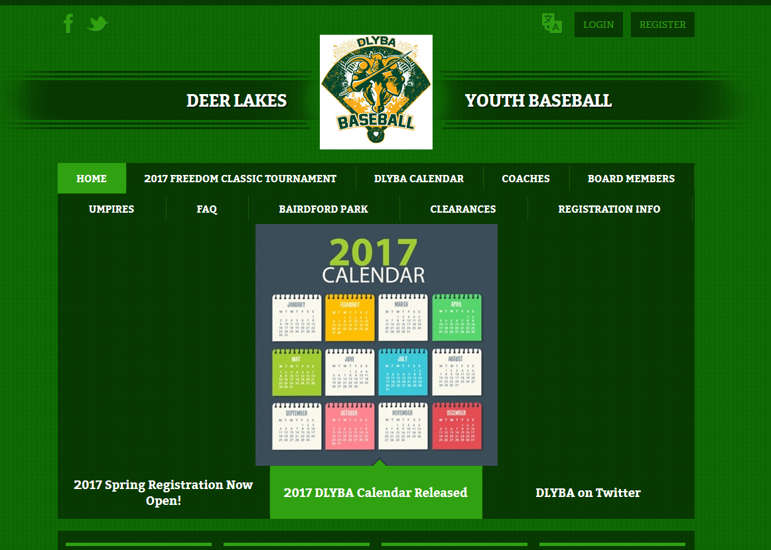

- After logging in, you will be taken to your account screen. Click on “Volunteer” on the left side of the page or the “Volunteer Opportunities” button on the top of the page.
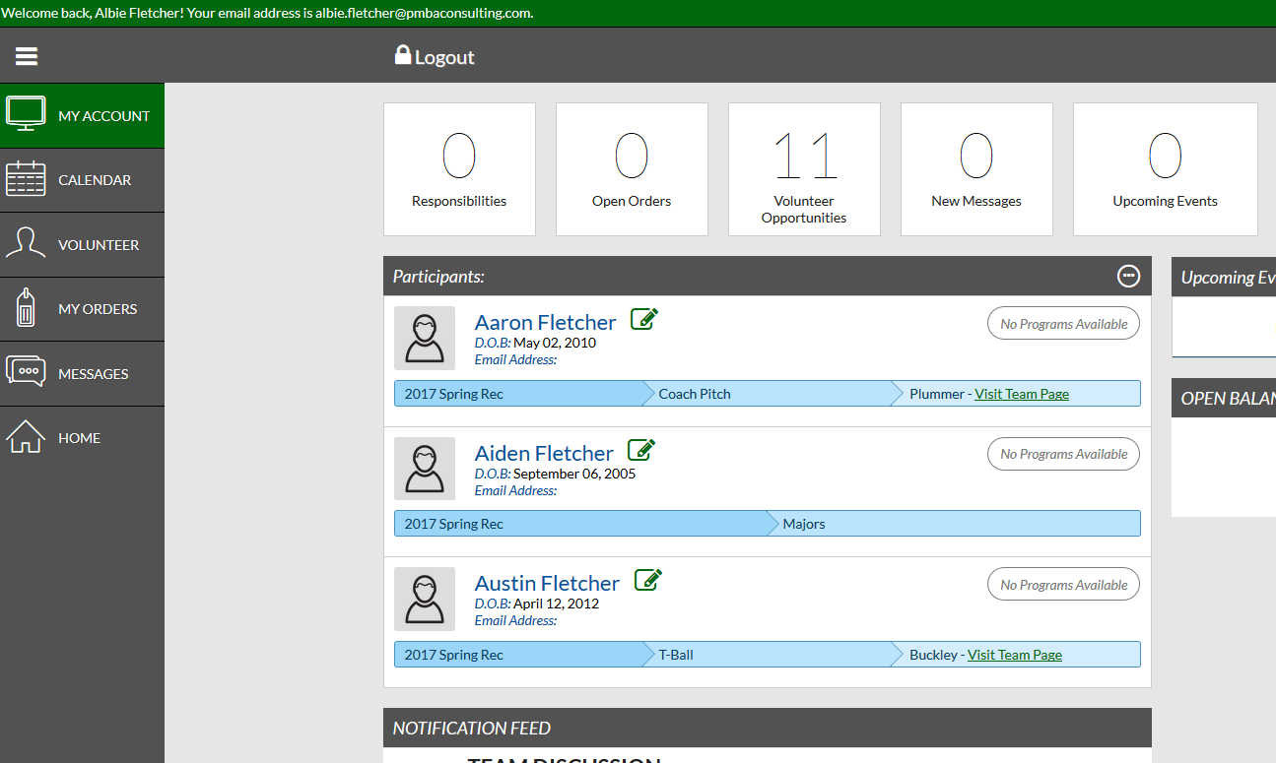

- Any role you currently volunteered for will be displayed. To find additional opportunities, select the “Find Volunteer Roles” button.
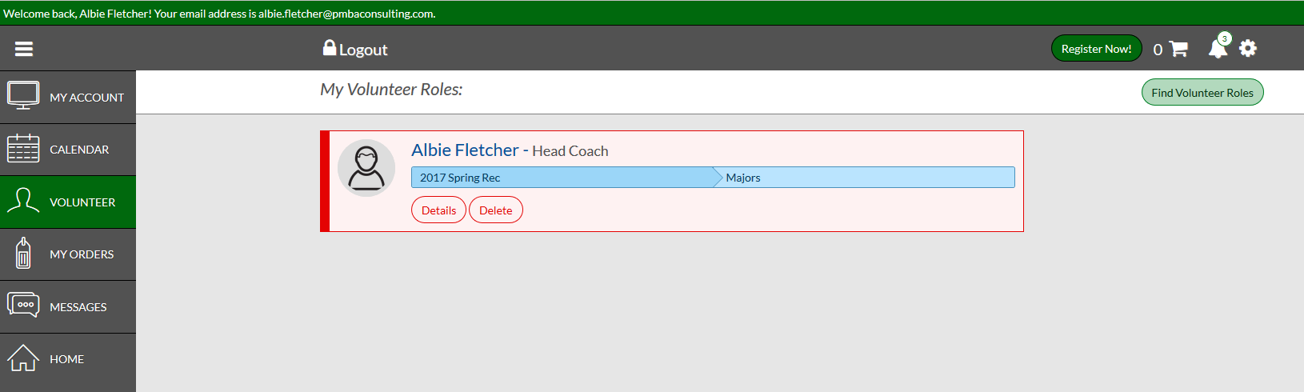

- Click the “Signup” button next to the role you would to volunteer for and hit Continue at the bottom of the screen
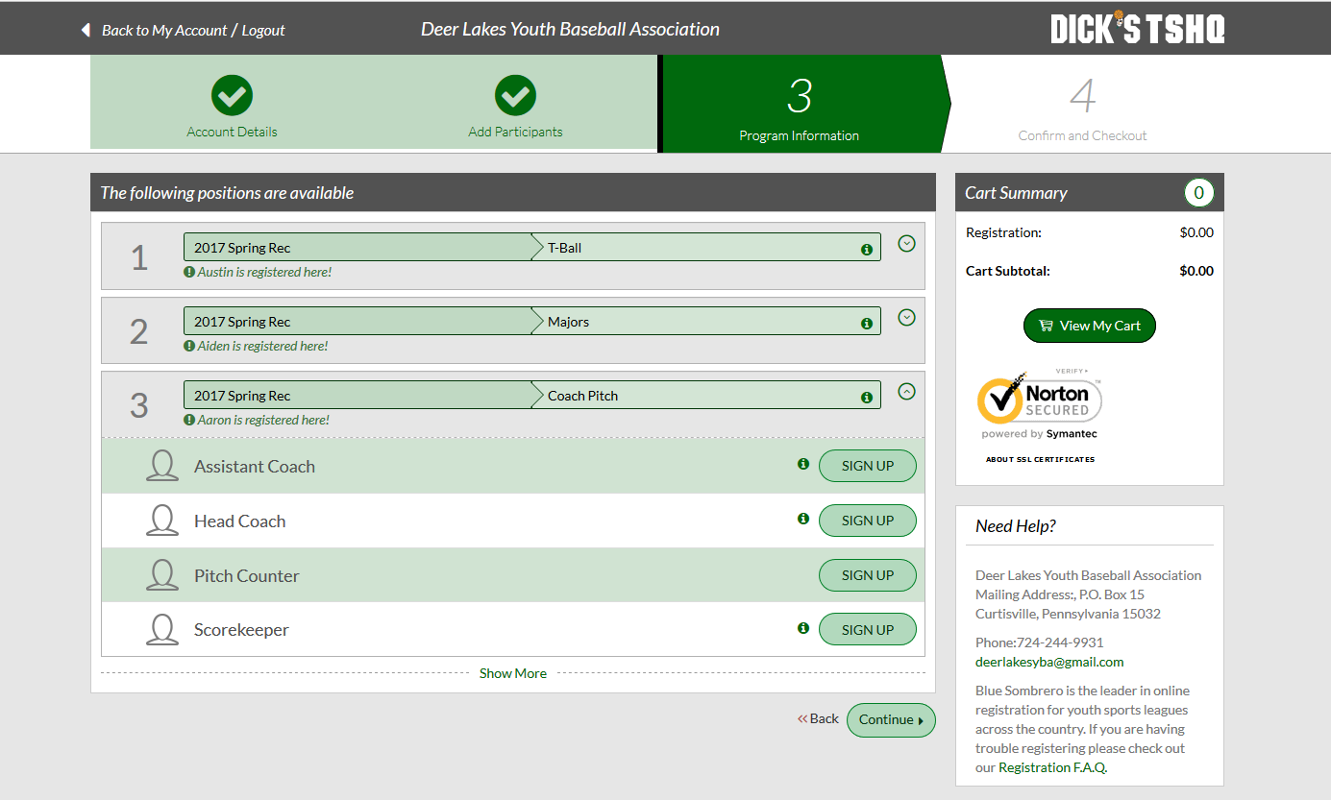

- Select the appropriate person and hit “Continue”
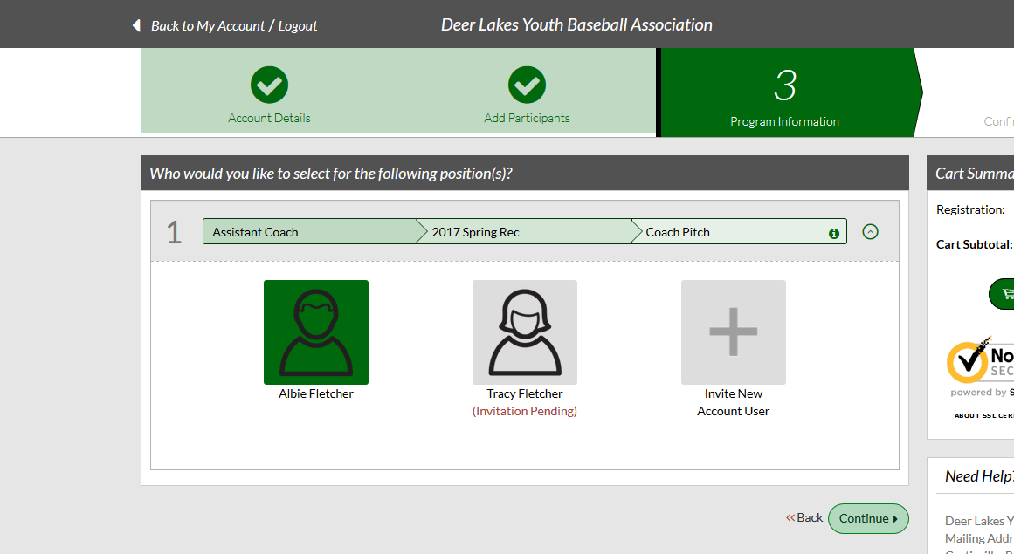

- Verify your information, accept any waivers and answers any additional questions (will vary based on volunteer role).
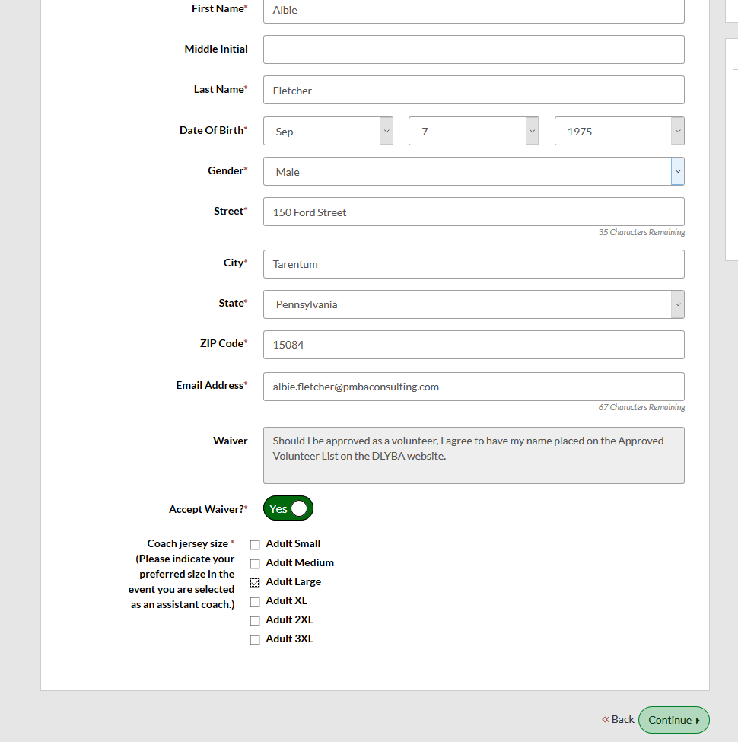

- Once completed, you will see your new role added to your account page,
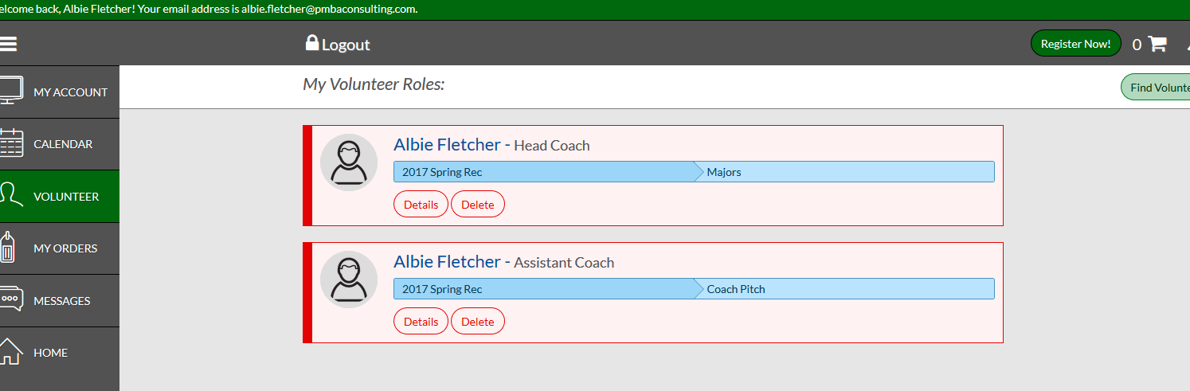

New Accounts
- Create account by clicking the register button on the website home page (http://www.dlyba.com)

- Select “Team Coach or Other Team Personnel”
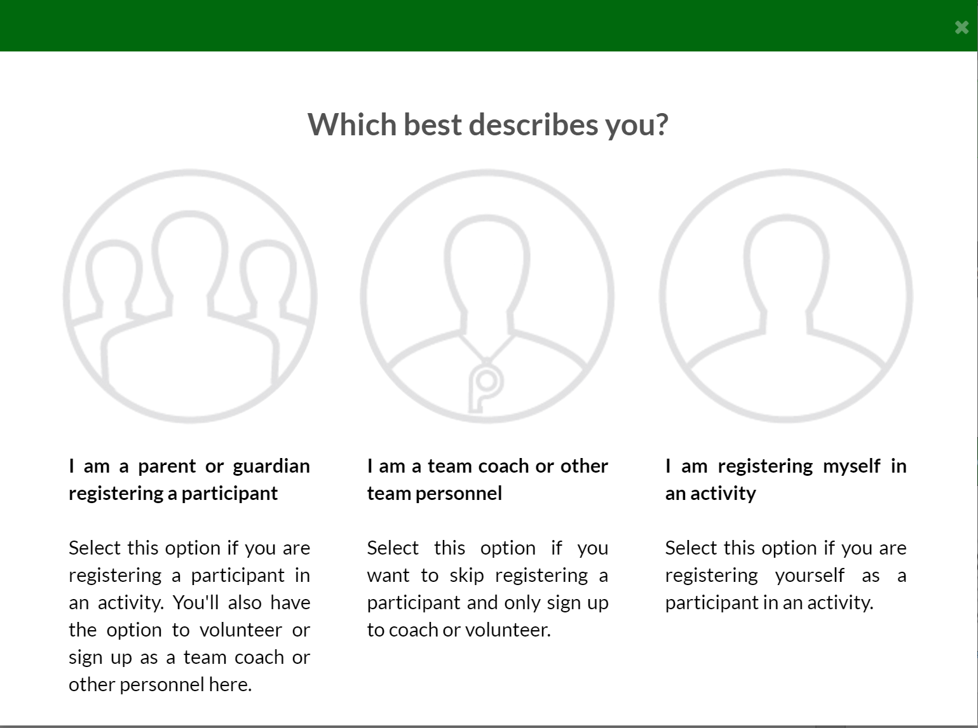
- Select applicable program and then click “View Roles”
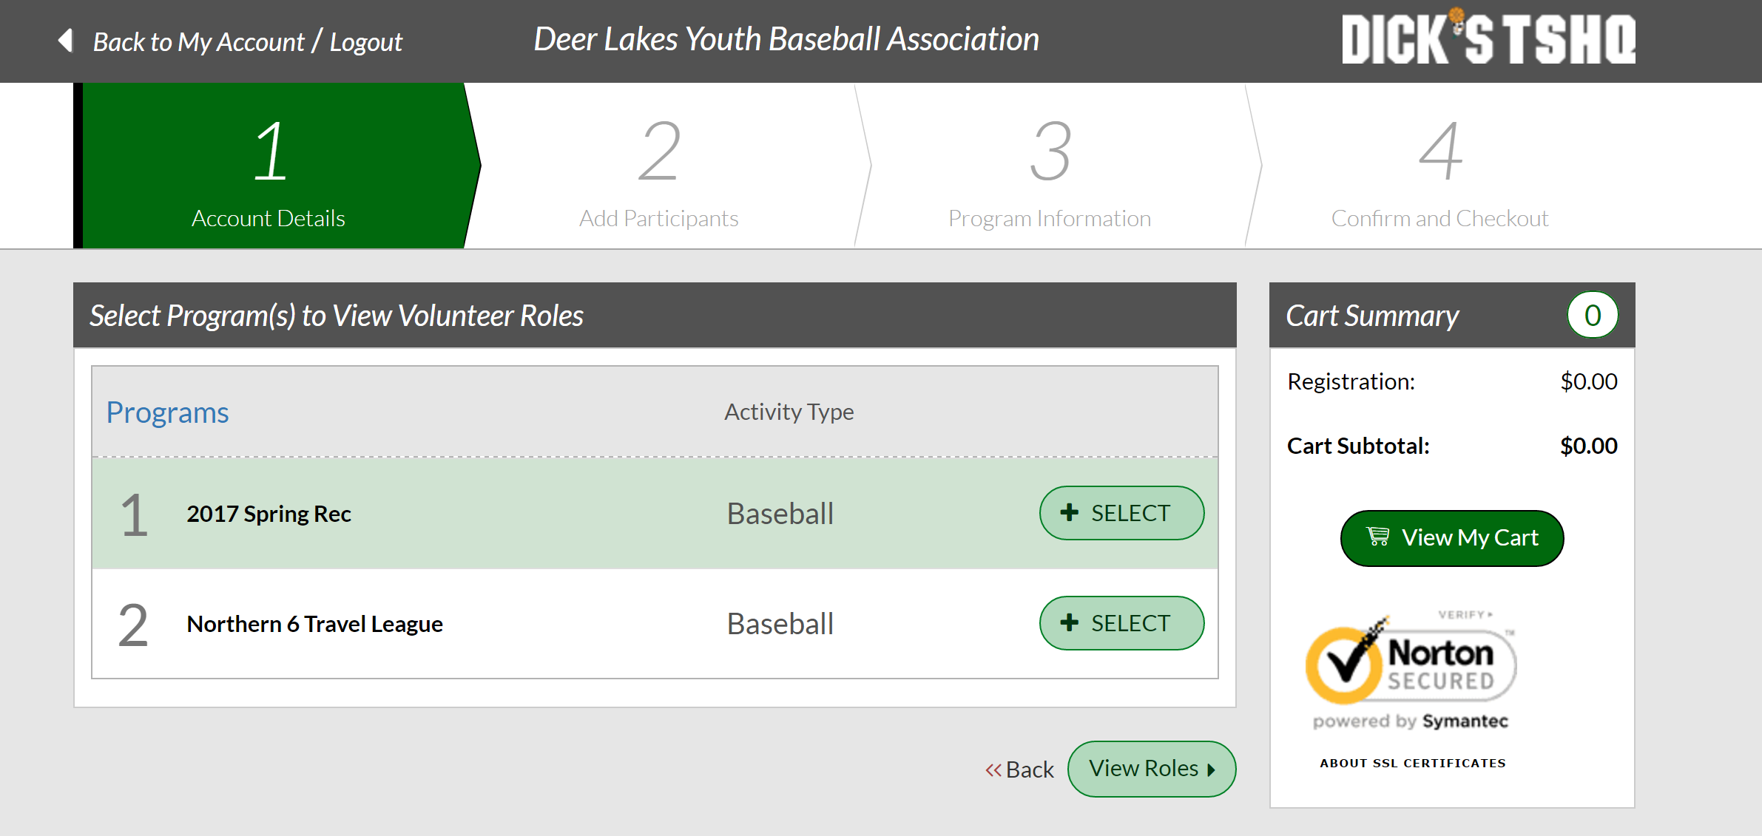

- Select the appropriate role by clicking the “Sign Up” button. It will turn to “Selected”. Then press the “Continue” button at the bottom of the page.
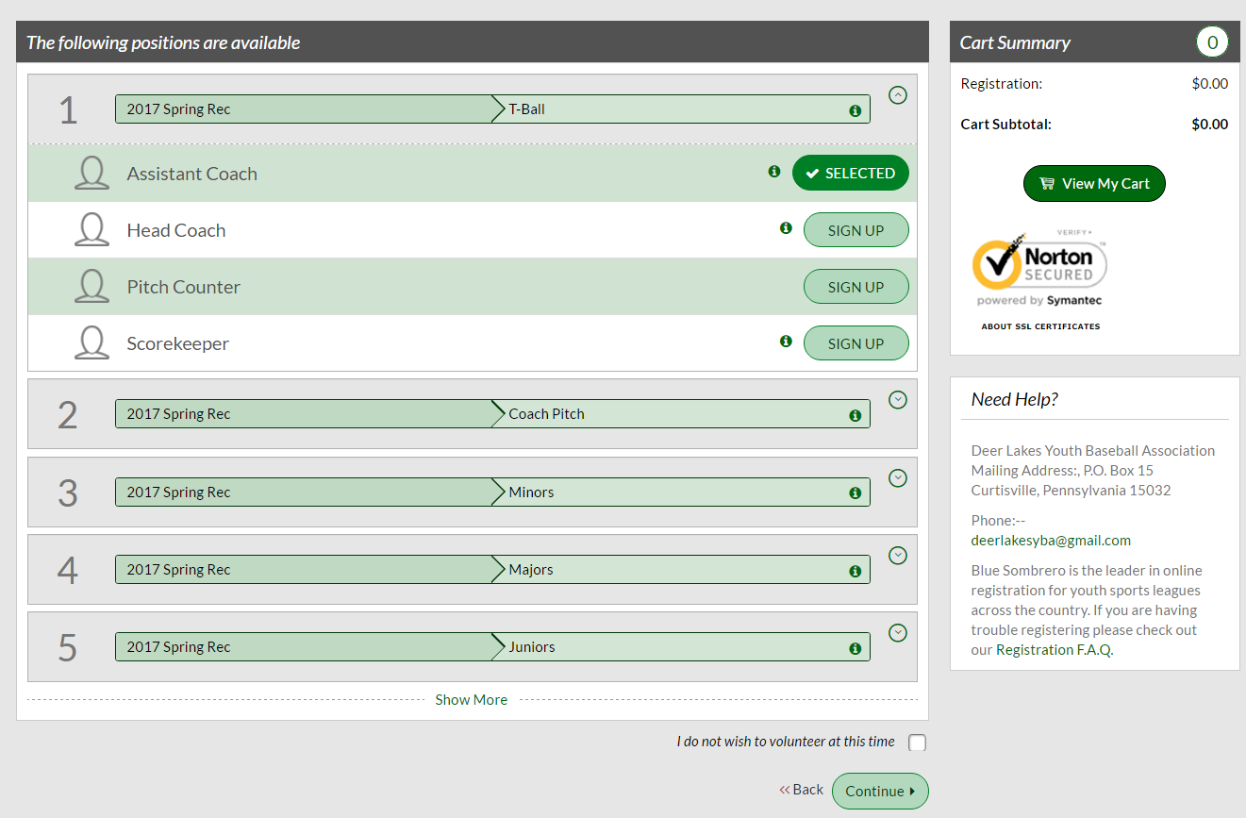

- Select the appropriate user (usually yourself) and hit “Continue” button.
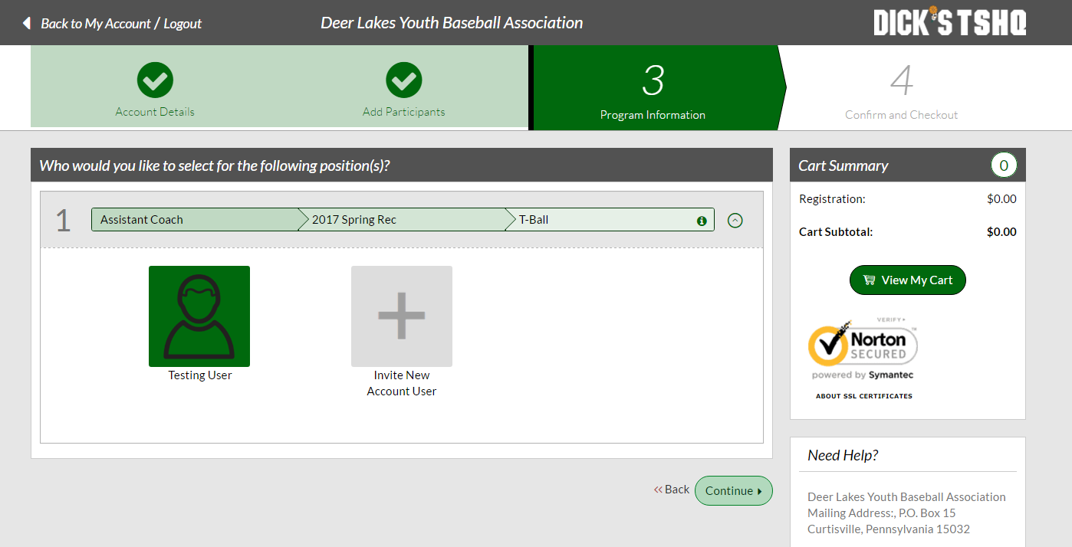
- Answer the questions that may be presented (will vary by role). Once completed you will see your volunteer role created.
